Chemical methods of gene delivery
- Cell membrane is a sheet like assembly of amphipathic molecules that separate cells from their environment. These physical structures allow only the controlled exchange of materials among the different parts of a cell and with its immediate surroundings. DNA is an anionic polymer, larger molecular weight, hydrophilic and sensitive to nuclease degradation in biological matrices. They cannot easily cross the physical barrier of membrane and enter the cells unless assisted.
- Chemical methods are transfection techniques that make use of carrier molecules to overcome the cell-membrane barrier. Different from what the name implicates, there are no chemical reactions taking place between the carrier molecule and the nucleic acid or any cellular component.
- The principle consists of the interaction of negatively charged nucleic acids with positively charged carrier molecules, like polymers or lipids, enabling the nucleic acid to come into contact with the negatively charged membrane components and incorporating the gene into the cell by endocytosis and later releasing it into the cytoplasm.
- These synthetic compounds are introduced near the vicinity of recipient cells thereby disturbing the cell membranes, widening the pore size and allowing the passage of the DNA into the cell.

An ideal chemical used for DNA transfer should have the ability to-
• Protect DNA against nuclease degradation.
• Transport DNA to the target cells.
• Facilitate transport of DNA across the plasma membrane.
• Promote the import of DNA into the nucleus.

The commonly used methods of chemical transfection use the following,
1.Lipofection
2. Calcium phosphate
3. DEAE dextran
4. Other polymers - poly-L-lysine (PLL), polyphosphoester, chitosan, dendrimers

- Liposome mediated gene transfer (Lipofection)
Lipofection, also known as “lipid transfection” or “liposome-based transfection,” uses a lipid complex to deliver DNA to cells.
Liposomes are artificial phospholipid vesicles used for the delivery of a variety of molecules into the cells. They may be multi-lamellar or unilamellar vesicles with a size range of 0.1 to 10 micrometer or 20-25 nanometers respectively.
They can be preloaded with DNA by two common methods- membrane-membrane fusion and endocytosis thus forming DNA- liposome complex. This complex fuses with the protoplasts to release the contents into the cell. Animal cells, plant cells, bacteria, yeast protoplasts are susceptible to lipofection method.
Liposomes can be classified as either cationic liposome or pH-sensitive.
- Cationic liposomes
- Cationic liposomes are positively charged liposomes which associate with the negatively charged DNA molecules by electrostatic interactions forming a stable complex.
- Neutral liposomes are generally used as DNA carriers and helpers of cationic liposomes due to their non-toxic nature and high stability in serum. A positively charged lipid is often mixed with a neutral co-lipid, also called helper lipid to enhance the efficiency of gene transfer by stabilizing the liposome complex (lipoplex). Dioleoylphosphatidyl ethanolamine (DOPE) or dioleoylphosphatidyl choline (DOPC) are some commonly used neutral co-lipids.
- The negatively charged DNA molecule interacts with the positively charged groups of the DOPE or DOPC. DOPE is more efficient and useful than DOPC due to the ability of its inverted hexagonal phase to disrupt the membrane integrity.
- The overall net positive charge allows the close association of the lipoplex with the negatively charged cell membrane followed by uptake into the cell and then into nucleus.
- The lipid: DNA ratio and overall lipid concentration used in the formation of these complexes is particularly required for efficient gene transfer which varies with application.

- Negatively charged liposomes
- Generally, pH-sensitive or negatively-charged liposomes are not efficient for gene transfer. They do not form a complex with it due to repulsive electrostatic interactions between the phosphate backbone of DNA and negatively charged groups of the lipids. Some of the DNA molecules get entrapped within the aqueous interior of these liposomes.
- However, formation of lipoplex, a complex between DNA and anionic lipidscan occur by using divalent cations (e.g. Ca2+, Mg2+, Mn2+, and Ba2+) which Can neutralize the mutual electrostatic repulsion. These anionic lipoplexes comprise anionic lipids, divalent cations, and plasmid DNA which are physiologically safe components.
- They are termed as pH sensitive due to destabilization at low pH.
The efficiency of both in vivo and in vitro gene delivery using cationic liposomes is higher than that of pH sensitive liposomes. But the cationic liposomes get inactivated and unstable in the presence of serum and exhibit cytotoxicity. Due to reduced toxicity and interference from serum proteins, pH-sensitive liposomes are considered as potential gene delivery vehicles than the cationic liposomes.
Liposome Action
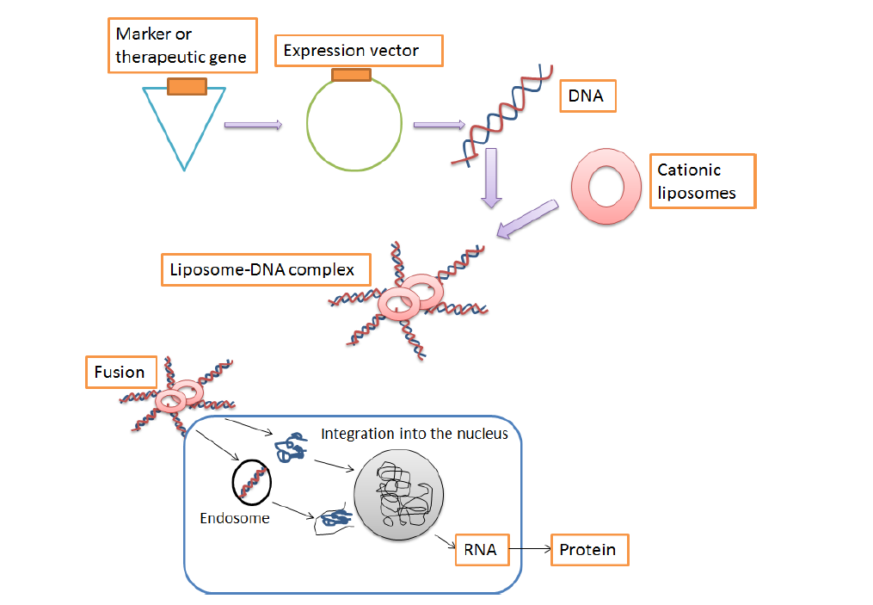
Figure: Schematic representation of liposome action in gene transfer
In addition, liposomes can be directed to cells using monoclonal antibodies which recognize and bind to the specific surface antigens of cells along with the liposomes. Liposomes can be prevented from destruction by the cell’s lysosomes by pre- treating the cells with chemicals such as chloroquine, cytochalasin B, colchicine etc. Liposome mediated transfer into the nucleus is still not completely understood.
Advantages
• Economic
• Efficient delivery of nucleic acids to cells in a culture dish.
• Delivery of the nucleic acids with minimal toxicity.
• Protection of nucleic acids from degradation.
• Measurable changes due to transfected nucleic acids in sequential processes.
• Easy to use, requirement of minimal steps and adaptable to high-throughput systems.

Disadvantages
• It is not applicable to all cell types.

- Calcium phosphate transfection
This method is based on the precipitation of plasmid DNA and calcium ions by their interaction.
In this method, the precipitates of calcium phosphate and DNA being small and insoluble can be easily adsorbed on the surface of cell. This precipitate is engulfed by cells through endocytosis and the DNA gets integrated into the cell genome resulting in stable or permanent transfection.
Uses
• This method is mainly used in the production of recombinant viral vectors.
• It remains a choice for plasmid DNA transfer in many cell cultures and packaging cell lines. As the precipitate so formed must coat the cells, this method is suitable only for cells growing in monolayer and not for suspension cultures.
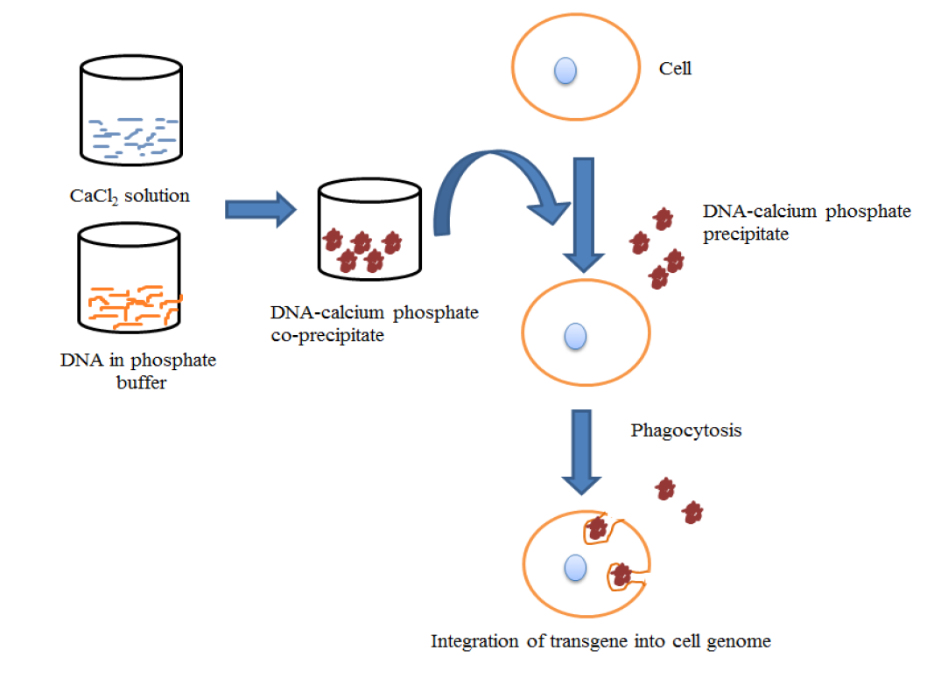
Figure: A schematic representation of transfection by Calcium phosphate precipitation
Advantages
• Simple and inexpensive
• Applicability to generate stably transfected cell lines
• Highly efficient (cell type dependent) and can be applied to a wide range of cell types.
• Can be used for stable or transient transfection
Disadvantages
• Toxic especially to primary cells
• Slight change in pH, buffer salt concentration and temperature can compromise the efficacy
• Relatively poor transfection efficiency compared to other chemical transfection methods like lipofection.
• Limited by the composition and size of the precipitate.
- DEAE-Dextran (Diethylaminoethyl Dextran) mediated DNA transfer
• Diethylaminomethyl dextran (DEAE-dextran) is a soluble polycationic carbohydrate that promotes interactions between DNA and endocytic machinery of the cell.
• In this method, the negatively charged DNA and positively charged DEAE – dextran form aggregates through electrostatic interaction and form a polyplex. A slight excess of DEAE – dextran in mixture results in net positive charge in the DEAE – dextran/ DNA complex formed. These complexes, when added to the cells, bind to the negatively charged plasma membrane and get internalized through endocytosis. Complexed DNA delivery with DEAE-dextran can be improved by osmotic shock using DMSO (Dimethyl sulfoxide) or glycerol.
• Several parameters such as number of cells, polymer concentration, transfected DNA concentration and duration of transfection should be optimized for a given cell line.
Advantages
• Simple and inexpensive
• More sensitive
• Can be applied to a wide range of cell types
• Can be used for transient transfection.
Disadvantages
• Toxic to cells at high concentrations
• Transfection efficiency varies with cell type
• Can only be used for transient transfection but not for stable transfection
• Typically produces less than 10% delivery in primary cells.

